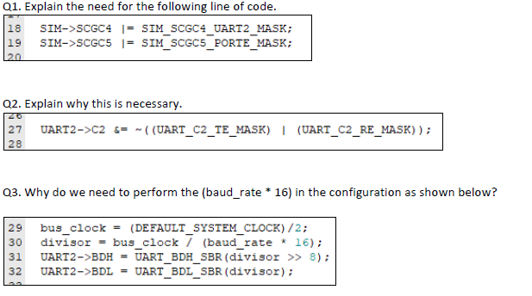
- It is to enable the clock for UART2 as well as PORTE
- This code is necessary because it is to ensure that no data is being transmitted or received during the initialization phase
- (baud_rate * 16) is due to the oversampling of UART2
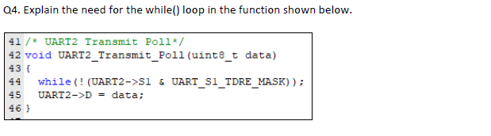
- The while() loop is to wait until all the data is transmitted
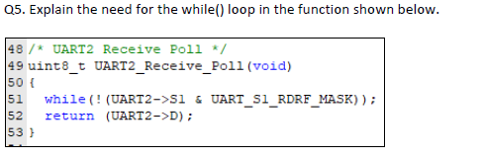
- The while() loop is to wait until the receive data register is full
- The waveform relates to the data being transferred as a logic high is a “1” and a logic low is a “0”

